Net 1060 Introduction to Networks Lab: # 10.3.4

Name:

Follow the instructions down below for the lab itself. For this lab, all answers need to be in blue font. For the questions right below, answer in complete sentences. Ensure you paste the screen shot of your score page at the bottom of the document. Even if this does not let you see your grade, still take a screen shot of the score page showing congratulations “your name” you have completed the exercise is pasted at the bottom of this document. You will then need to upload both this word document and your packet tracer file to the assignments link within Netacad. Let the instructor know if you have any questions.

Lab Analysis Report

1. Using complete sentences summarize work you completed during the lab.
First, I displayed and analyzed the interfaces and router information for R1 and R2. Then I configured the Gigabitethernet connections and their IP addresses on R1 and R2. Finally I verified the connection by looking at the route table and pinging other devices on the network.

2. Using complete sentences describe what you learned from the lab. Hint; look at the lab objectives listed at the top of the lab section.
In this lab I learned about the different ways you can look at connections on networks. I also learned about how to configure interfaces and get them up and running.

Problems Encountered

1. Using complete sentences describe any problem(s) experienced during lab.
I didn’t experience any problems during this lab.

2. Using complete sentences describe how you solved your problem(s).

3. Using complete sentences explain if you needed any assistance with the lab; then list what you learned from that assistance.

Packet Tracer - Connect a Router to a LAN

Addressing Table
Device | Interface | IP Address | Subnet Mask | Default Gateway
R1 | G0/0 | 192.168.10.1 | 255.255.255.0 | N/A
R1 | G0/1 | 192.168.11.1 | 255.255.255.0 | N/A
R1 | S0/0/0 (DCE) | 209.165.200.225 | 255.255.255.252 | N/A
R2 | G0/0 | 10.1.1.1 | 255.255.255.0 | N/A
R2 | G0/1 | 10.1.2.1 | 255.255.255.0 | N/A
R2 | S0/0/0 | 209.165.200.226 | 255.255.255.252 | N/A
PC1 | NIC | 192.168.10.10 | 255.255.255.0 | 192.168.10.1
PC2 | NIC | 192.168.11.10 | 255.255.255.0 | 192.168.11.1
PC3 | NIC | 10.1.1.10 | 255.255.255.0 | 10.1.1.1
PC4 | NIC | 10.1.2.10 | 255.255.255.0 | 10.1.2.1

Objectives
Part 1: Display Router Information
Part 2: Configure Router Interfaces
Part 3: Verify the Configuration

Background
In this activity, you will use various show commands to display the current state of the router. You will then use the Addressing Table to configure router Ethernet interfaces. Finally, you will use commands to verify and test your configurations.
Note: The routers in this activity are partially configured. Some of the configurations are not covered in this course but they are provided to assist you in using verification commands.

Display Router Information

Display interface information on R1.
Note: Click a device and then click the CLI tab to access the command line directly. The console password is cisco. The privileged EXEC password is class.

Questions:
    - Which command displays the statistics for all interfaces configured on a router?
Show interfaces is the command. your answers here.
    - Which command displays the information about the Serial 0/0/0 interface only?
Show interfaces Serial 0/0/0 is the command.Type your answers here.
    - Enter the command to display the statistics for the Serial 0/0/0 interface on R1 and answer the following questions:
      - What is the IP address configured on R1?
209.165.200.255 is the IP address for R1. your answers here.
      - What is the bandwidth on the Serial 0/0/0 interface?
The bandwidth is 1544 kilobits/sec. your answers here.
    - Enter the command to display the statistics for the GigabitEthernet 0/0 interface and answer the following questions:
      - What is the IP address on R1?
There is no IP address on for GigabitEthernet 0/0.
      - What is the MAC address of the GigabitEthernet 0/0 interface?
The MAC address is 000d.bd6c.7d01. your answers.
      - What is the bandwidth (BW) of the GigabitEthernet 0/0 interface?
The BW is 1000000 Kbit/sec. your answers here.

Display a summary list of the interfaces on R1.

Questions:
    - Which command displays a brief summary of the current interfaces, interface status, and the IP addresses assigned to them?
The command is show IP interface brief your answers here.
    - Enter the command on each router and answer the following questions:
      - How many serial interfaces are there on R1 and R2?
There are two serial interfaces on R1 and two on R2. your answers here.
      - How many Ethernet interfaces are there on R1 and R2?
There are six Ethernet interfaces on R1 and two on R2. your answers here.
      - Are all the Ethernet interfaces on R1 the same? If no, explain the difference(s).
No, there is GigabitEthernet and FastEthernet. GigabitEthernet has higher speeds than FastEthernet.your answers here.

Display the routing table on R1.

Questions:
    - What command displays the contents of the routing table?
The command is show ip route. your answers here.
    - Enter the command on R1 and answer the following questions:
      - How many connected routes are there (uses the C code)?
The is one connected route. your answers here.
      - Which route is listed?
The Serial 0/0/0 route is the only one connected. your answers here.
      - How does a router handle a packet destined for a network that is not listed in the routing table?
The router will drop the packet if it’s not listed in the table. your answers here.

Configure Router Interfaces

Configure the GigabitEthernet 0/0 interface on R1.
    - Enter the following commands to address and activate the GigabitEthernet 0/0 interface on R1:
Open configuration window
R1(config)# interface gigabitethernet 0/0
R1(config-if)# ip address 192.168.10.1 255.255.255.0
R1(config-if)# no shutdown
%LINK-5-CHANGED: Interface GigabitEthernet0/0, changed state to up
%LINEPROTO-5-UPDOWN: Line protocol on Interface GigabitEthernet0/0, changed state to up
    - It is good practice to configure a description for each interface to help document the network. Configure an interface description that indicates the device to which it is connected.
R1(config-if)# description LAN connection to S1
    - R1 should now be able to ping PC1.
R1(config-if)# end
%SYS-5-CONFIG_I: Configured from console by console
R1# ping 192.168.10.10

Type escape sequence to abort.
Sending 5, 100-byte ICMP Echos to 192.168.10.10, timeout is 2 seconds:
.!!!!
Success rate is 80 percent (4/5), round-trip min/avg/max = 0/2/8 ms

Configure the remaining Gigabit Ethernet Interfaces on R1 and R2.
    - Use the information in the Addressing Table to finish the interface configurations for R1 and R2. For each interface, do the following:
      - Enter the IP address and activate the interface.
      - Configure an appropriate description.
    - Verify interface configurations.

Back up the configurations to NVRAM.

Question:
Save the configuration files on both routers to NVRAM. What command did you use?
The command copy running-config startup-config was used. your answers here.
Close configuration window

Verify the Configuration

Use verification commands to check your interface configurations.
    - Use the show ip interface brief command on both R1 and R2 to quickly verify that the interfaces are configured with the correct IP address and are active.

Questions:
How many interfaces on R1 and R2 are configured with IP addresses and in the “up” and “up” state?
There are three interfaces on R1 and three on R2.your answers here.
What part of the interface configuration is NOT displayed in the command output?
The subnet mask is not displayed. your answers here.
What commands can you use to verify this part of the configuration?
You can use the show interfaces command to verify this. your answers here.
    - Use the show ip route command on both R1 and R2 to view the current routing tables and answer the following questions:

Questions:
      - How many connected routes (uses the C code) do you see on each router?
There are three connected routes on R1 and R2. your answers here.
      - How many OSPF routes (uses the O code) do you see on each router?
There are two OSPF routes on R1 and R2. your answers here.
      - If the router knows all the routes in the network, then the number of connected routes and dynamically learned routes (OSPF) should equal the total number of LANs and WANs. How many LANs and WANs are in the topology?
There are four LANs and WANs total. your answers here.
      - Does this number match the number of C and O routes shown in the routing table?
Type Yes the numbers match. here.
Note: If your answer is “no”, then you are missing a required configuration. Review the steps in Part 2.

Test end-to-end connectivity across the network.
You should now be able to ping from any PC to any other PC on the network. In addition, you should be able to ping the active interfaces on the routers. For example, the following tests should be successful:
- From the command line on PC1, ping PC4.
- From the command line on R2, ping PC2.
Note: For simplicity in this activity, the switches are not configured. You will not be able to ping them.
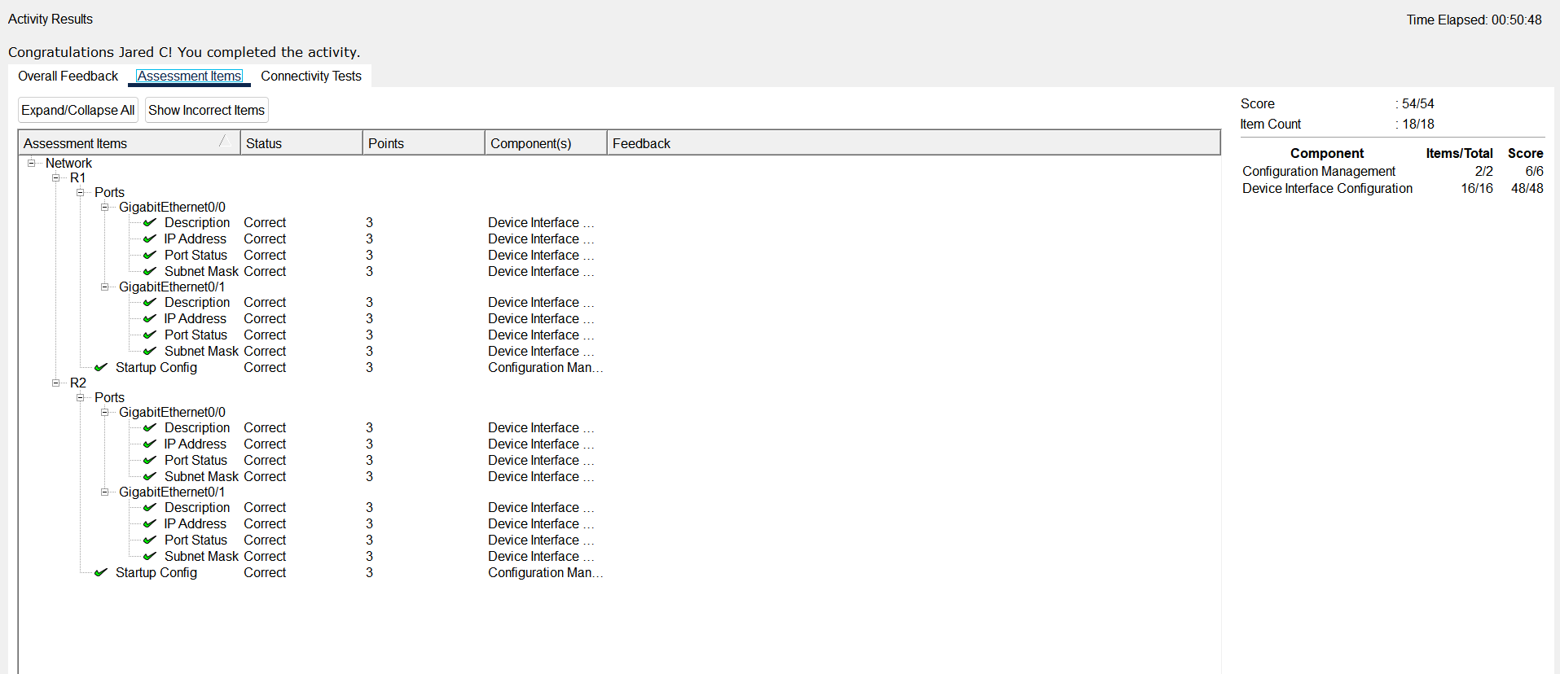
End of document

